Test Case: tc006_SPX_Dev5_Crear_Requisicion_Spot_Tipo_Cobro_Proyect_Urgent
Step 1 - Enter username and password and click to button Enter: Credentials Entered
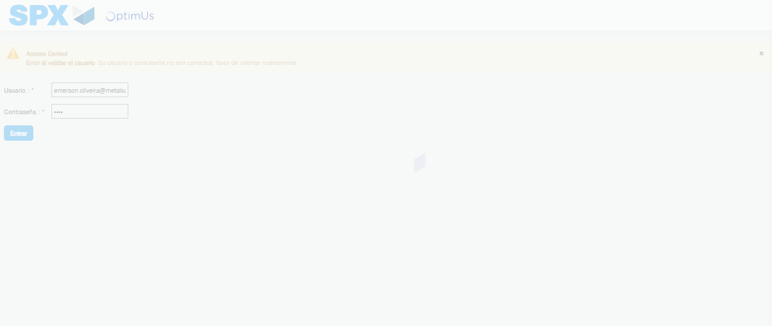Image file-name: QC_Testing-tc006_SPX_Dev5_Crear_Requisicion_Spot_Tipo_Cobro_Proyect_Urgent-1787008992043

Step 2 - Select to UEN and Access to Spot Buy Requisitions : UEN Correctly selected and Correct access
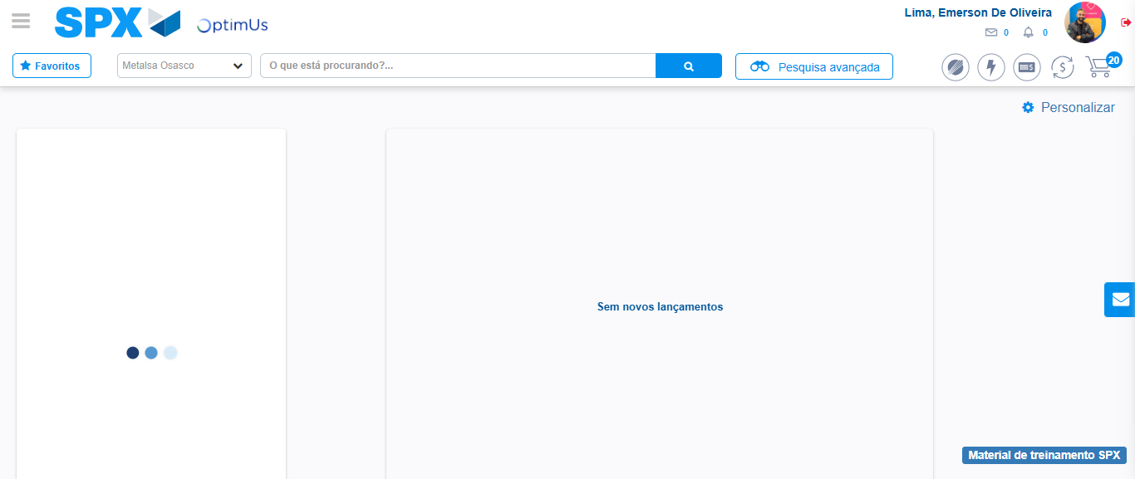Image file-name: QC_Testing-tc006_SPX_Dev5_Crear_Requisicion_Spot_Tipo_Cobro_Proyect_Urgent-1787009019693

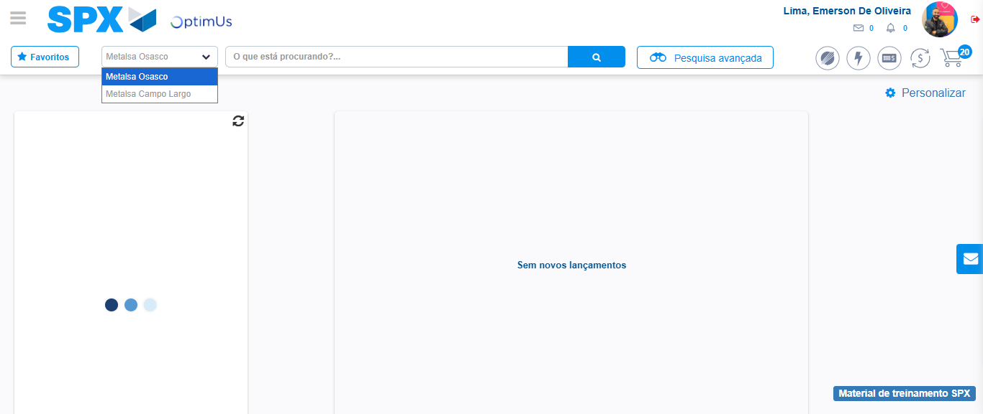Image file-name: QC_Testing-tc006_SPX_Dev5_Crear_Requisicion_Spot_Tipo_Cobro_Proyect_Urgent-1787009022325

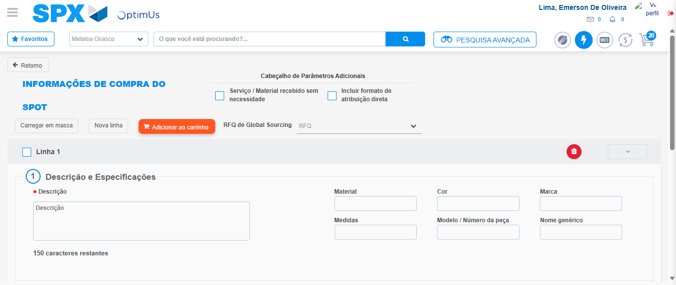Image file-name: QC_Testing-tc006_SPX_Dev5_Crear_Requisicion_Spot_Tipo_Cobro_Proyect_Urgent-1787009044910

Step 3 - Data Capture Spot Buy Requisition: Data captured correctly
Image file-name: QC_Testing-tc006_SPX_Dev5_Crear_Requisicion_Spot_Tipo_Cobro_Proyect_Urgent-1787009045250

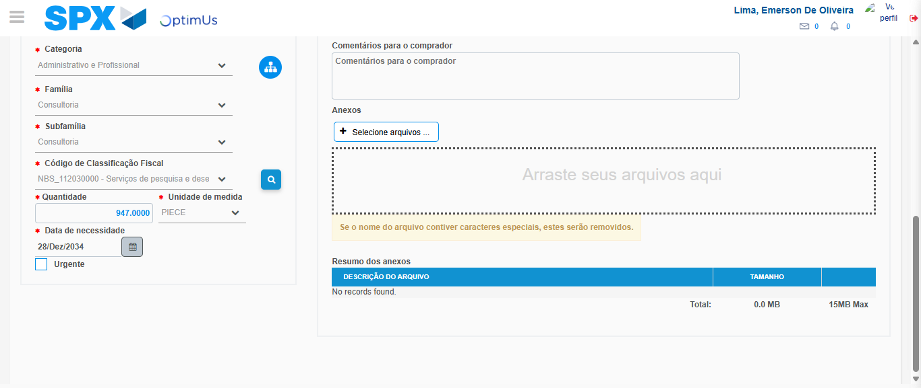Image file-name: QC_Testing-tc006_SPX_Dev5_Crear_Requisicion_Spot_Tipo_Cobro_Proyect_Urgent-1787009063368

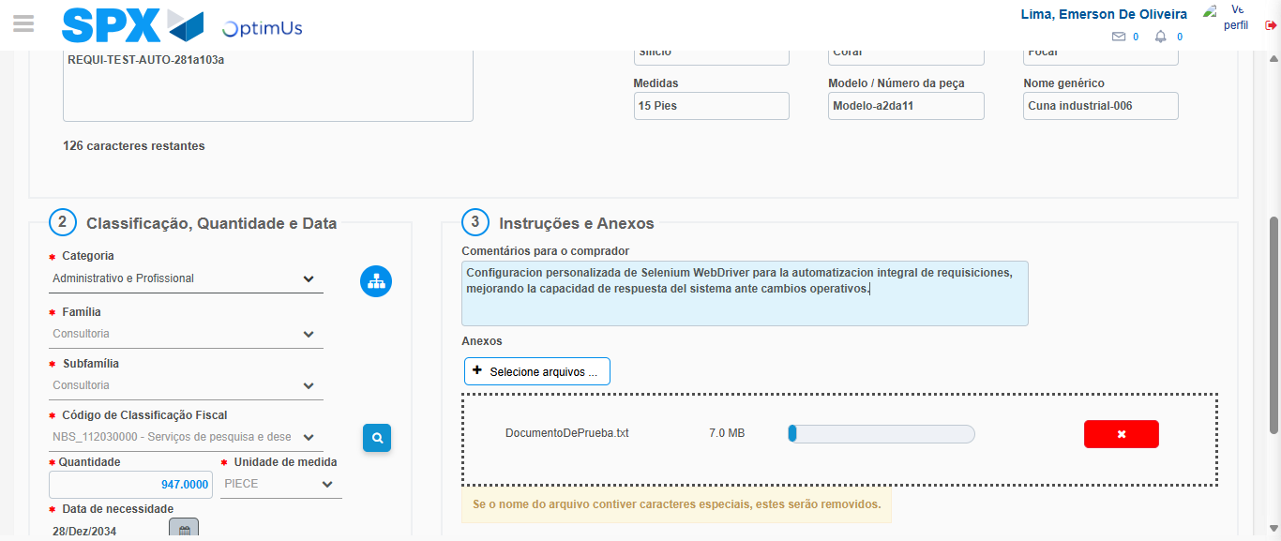Image file-name: QC_Testing-tc006_SPX_Dev5_Crear_Requisicion_Spot_Tipo_Cobro_Proyect_Urgent-1787009064368

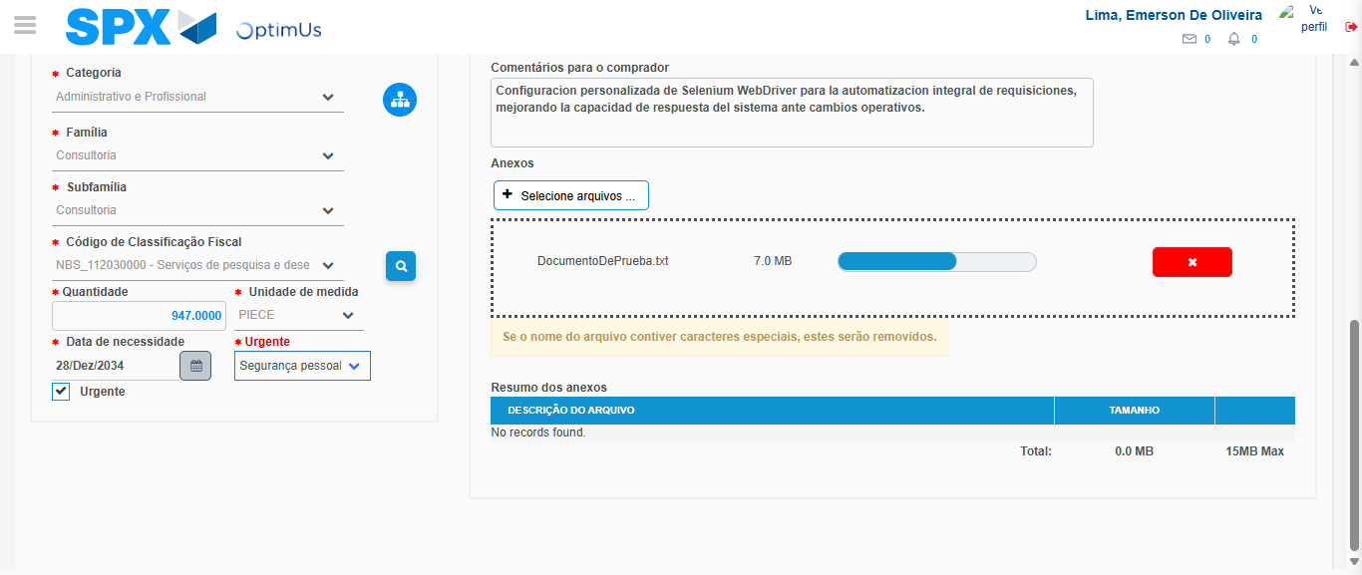Image file-name: QC_Testing-tc006_SPX_Dev5_Crear_Requisicion_Spot_Tipo_Cobro_Proyect_Urgent-1787009068245

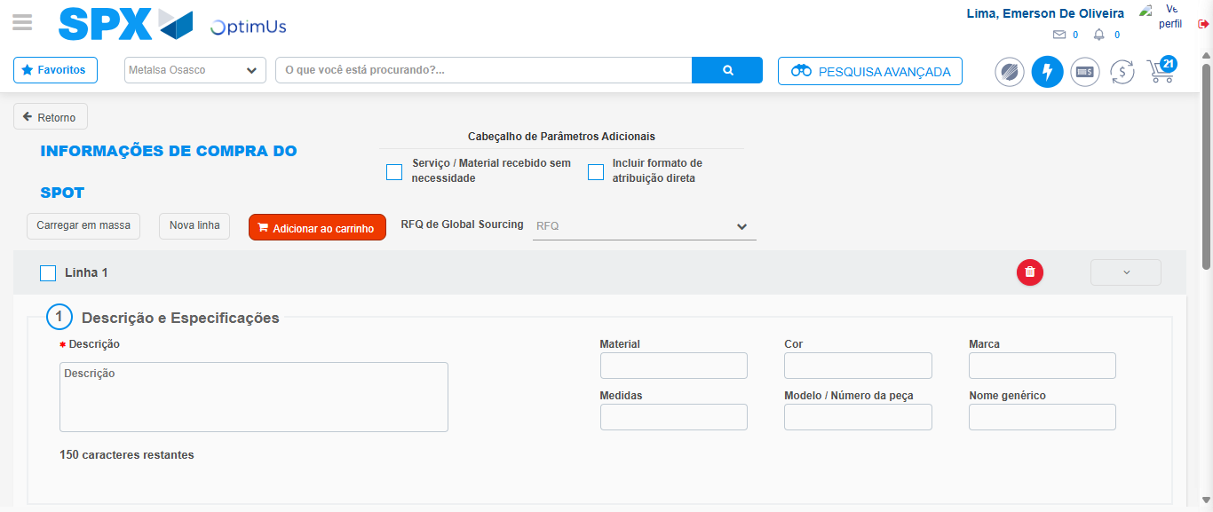Image file-name: QC_Testing-tc006_SPX_Dev5_Crear_Requisicion_Spot_Tipo_Cobro_Proyect_Urgent-1787009074878

Step 7 - Return to Main Page SPX : Return to Main Page SPX
Image file-name: QC_Testing-tc006_SPX_Dev5_Crear_Requisicion_Spot_Tipo_Cobro_Proyect_Urgent-1787009019693

Image file-name: QC_Testing-tc006_SPX_Dev5_Crear_Requisicion_Spot_Tipo_Cobro_Proyect_Urgent-1787009022325

Image file-name: QC_Testing-tc006_SPX_Dev5_Crear_Requisicion_Spot_Tipo_Cobro_Proyect_Urgent-1787009044910

Image file-name: QC_Testing-tc006_SPX_Dev5_Crear_Requisicion_Spot_Tipo_Cobro_Proyect_Urgent-1787009077174

Image file-name: QC_Testing-tc006_SPX_Dev5_Crear_Requisicion_Spot_Tipo_Cobro_Proyect_Urgent-1787009077443

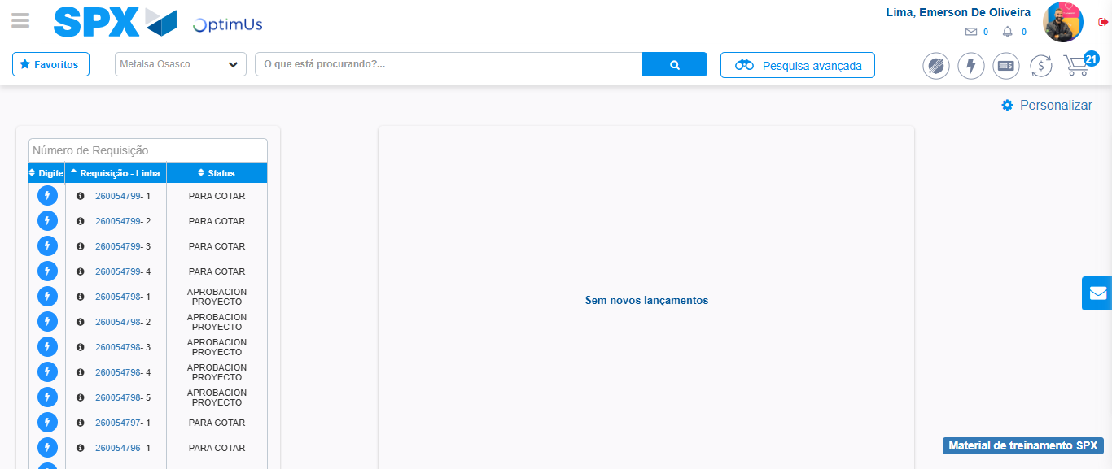Image file-name: QC_Testing-tc006_SPX_Dev5_Crear_Requisicion_Spot_Tipo_Cobro_Proyect_Urgent-1787009098602

Step 8 - Log Out : Log Out SPX
Image file-name: QC_Testing-tc006_SPX_Dev5_Crear_Requisicion_Spot_Tipo_Cobro_Proyect_Urgent-1787009098825

